#### DESN445 Interaction design III



Reading worksheet

**Source 1**: *Staler R.H. & Sunstein C.R.* **Nudge: Introduction.** <https://drive.google.com/file/d/15UvmdC-JeYH43ofzQV-zfvWczgXIvyOD/view?usp=sharing>

* Display and arrangement of a product is critical in the decision making process.
* Libertarian Paternalism: Gives people freedom of choice, while also nudging them toward the choice most beneficial for the chooser.
  + Possible solution based on the idea that people tend to make bad decisions.
  + Has been used many times before in government and private sectors.
* Combination of incentives and nudges influence people's choice.
* A false assumption and two misconceptions
  + false assumption: people will always make choices in their best interest.
    - “They do less well in contexts in which they are inexperienced and poorly informed, and in which feedback is slow or infrequent”
  + misconception one: it’s possible to avoid influencing people’s choices.
    - neutrality; choosing randomly or choosing the medium is still a choice
    - unintentional nudges can have major effects, which can be unattractive
  + misconception two: paternalism always involves coercion.
    - “In the cafeteria example, the choice of the order in which to present food items does not force a particular diet on anyone, yet Carolyn, and others in her position, might select some arrangement of food on grounds that are paternalistic in the sense that we use the term. Would anyone object to putting the fruit and salad before the desserts at an elementary school cafeteria if the result were to induce kids to eat more apples and fewer Twinkies?”
* “Choice architects can make major improvements to the lives of others by designing user-friendly environments.”

**Source 2**: *Dunne A. & Raby F.* (2013). **Speculative everything: Design Fiction and Social Dreaming: Chapter 1.** *Massachusetts Institute of Technology.*  
<https://drive.google.com/file/d/1UDfrYj8OKbl5Bttk2-zOjbb6-iMp5oqP/view?usp=sharing>

* (BJ) Speculative design is meant to open dialog about what the future could look like not predict what it will be.
* (BJ) Areas designers work in:
  + Future Predictions
    - what we want and don’t want to see in the future
      * Rarely do people correctly guess the future / what humans will do.
  + Probable
    - What is likely going to happen (most designers work in this space)
  + Plausible
    - What could happen ( scenarios, planning and foresight)
  + Possible
  + Makes links between todays world and the future predictions by assessing the scentific possibities and creating believable scenarios and events.
    - Critical reflection of users
    - aids in reflection

* + Fantasy
  + There are very few links to reality and is considered pure speculation
  + Probable and Plausible
    - Preferable future outcomes
* (BJ)Society has confined design through captialistic means, design became focused on earning money and less on improving society through exploratory design.

##### Quotes / Interesting Content

(BJ) “many of the challenges we face today are unfixable and that the only way to overcome them is by changing our values, beliefs, attitudes, and behavior.”

(BJ) “Design became fully integrated into the neoliberal model of capitalism that emerged during the 1980s, and all other possibilities for design were soon viewed as economically unviable and therefore irrelevant.”

(BJ) “revisit our social dreams and ideals and design’s role in facilitating alternative visions rather than defining them … being a catalyst rather than a source of visions.”

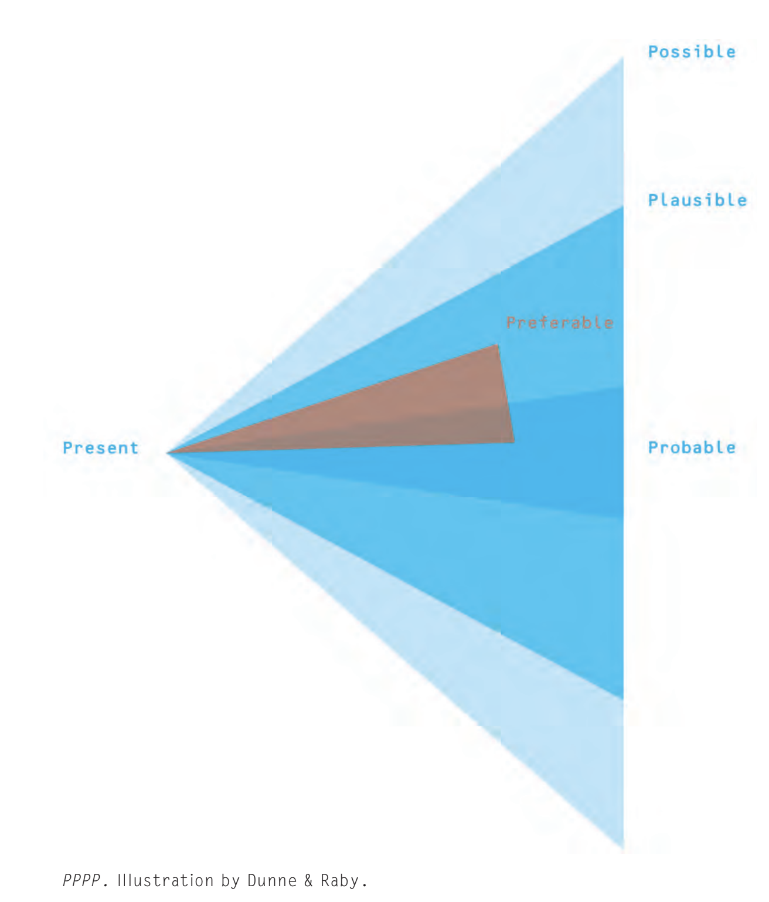

**Source 3**: *Norman D.A. & Verganti R.* (2012). **Norman on Innovation, radical and incremental:** *Nielsen Norman Group.* <https://drive.google.com/file/d/15V0B1Bp6ODYagF25nC0AepNq7ScdC6es/view?usp=sharing>

##### Quotes / Interesting Content

* “hill-climbing… guarantees continual improvement with eventual termination at the peak of the hill,… there is no way to know whether there might be even higher hills in some other part of the design space… Radical innovation seeks the highest hill.”
* “The concept “research” takes two different forms in design. One perspective sees research as exploration and experimentation that leads to the advancement of knowledge, the development of theories and the application of theories…[the] second perspective, design research focuses upon how to improve both products and sales.”

**Source 4**: [The full spectrum: Service design and autism services - Province of British Columbia (gov.bc.ca)](https://www2.gov.bc.ca/gov/content/governments/services-for-government/service-experience-digital-delivery/service-design/case-studies/the-full-spectrum-service-design-and-autism-services)

* “The program provides yearly funding and parents must plan and manage their own spending and submit for reimbursements—processes that required a lot of forms and admin time. Parents had to use two separate websites to find information, one focused on funding and one dedicated to information and support.”
  + The necessary information for the parents is not localized to a single website they can access easily.
* “The autism program consists of three teams; funding, information services, and policy. They were all focused on the website as the key to improving their services and increasing portal use.”
  + Inclusion of a funding and policy team shows
* “Ultimately, the project had four goals:
* Understand the experience of parents, autism service providers, and MCFD staff when accessing or delivering services
* Explore the existing direction of government autism services to see what was working well and what could be improved
* Identify and implement opportunities to improve the service for families and MCFD staff
* Build the capacity of the autism program to take a human-centred approach to service design at the completion of the project
* ”
  + Service design in a government organization.
* The solution  
   “**The policy is the service.** ”
  + - reworded the autism handbook to use plain language
  + “**One stop shop for autism info and support.**”
    - Centralizes the information to a single location
  + “**Profile personal support.**”
    - Focus on a personalized experience for the parent
  + “**An ongoing human-centred approach to service design.**”
    - Support from the staff and help parents traverse the website

**Source 5**: *Einfeldt, Lasse & Degbelo, Auriol.* (2021). **User Interface Factors of Mobile UX: A Study with an Incident Reporting Application.** [(PDF) User Interface Factors of Mobile UX: A Study with an Incident Reporting Application (researchgate.net)](https://www.researchgate.net/publication/349045093_User_Interface_Factors_of_Mobile_UX_A_Study_with_an_Incident_Reporting_Application)

* “Our understanding of user interface factors which maximize mobile user experience is still limited.”
* Investigating these factors is important for at least two reasons:
  + mobile is unique; size is different, space and processing power is limited, and input is different from desktop.
  + Understanding of these factors is important to develop design heuristics; constraints during computer generated user interface design.
* “Incident reporting apps (of which maps are a central component)”
  + geospatial maps are considered important in reporting applications.
  + no consolidated set of guidelines on how to interact with the map
* positive user experience is crucial to guaranteed prolonged contributions by citizens
* “sequence of UI elements matter while trying to maximize mobile”
* Mention of Harms et al. (2015) comparing a study of form lengths (short and long) with navigation types (tab or scroll)
  + Harms et al. findings indicated long forms performed worse as scrollable nav than tab nav.
* “They found users to prefer a selection of reportable items from a menu.”
  + overview of all items, and removed generalized form
* “...necessity to provide identification to avoid fake reporting.”
  + pictures and video included.
* “the participation of citizens in monitoring the quality of the environment they live in”

**Source 6**: Bill Buxton. Wild Design for living in the wild:<https://vimeo.com/319235304> (from 13:35 to 39:00)

* wave 0; no mobility, technology restriction.
* wave 1; pdas, calculator started, storing limited memory in mobile format.
  + more successful product involved the least amount of complex user interaction (single push of a button; data sync).
  + integration and developing a social relationship with other technologies.
  + seamless flow of data at almost 0 cost.
* wave 2: smart phones
  + early (first) iteration of the smartphone - had almost all the same features as the iphone except browser, as the internet wasn't invented yet.
  + first broadly available consumer device that had an analog interface. Flow was smooth. (success of the iphone)
* wave 3: an ecosystem
  + “Mobility is no longer associated with a single device or technology.”
  + “Rather, it refers to human activity (which has always been the case).”
  + “Dynamically supported by whatever appropriate technology available & relevant.”
* The next big thing is a social change in the relationship of things.
* Smart cars are stupid cars, Ford has the best thing with the sensor to open the trunk.
  + Next big thing; utilize car sensor data for personalized experiences of paying customers who've paid 30-40,000 dollars.
  + Rental cars with paired data of other users, idea of bounded kinships with specific trust, pair with phone and car through bluetooth.
  + Language of sociology; introduce and kinship
* Complexity and the threshold of frustration

**Source 7**: How we enhanced Chicago’s public transit with Augmented Reality: Automatic sign detection and routing visualization: <https://blog.truthlabs.com/chicago-cta-augmented-reality-sign-detection-visualization-bus-data-application-design-7f8fe2f2f6b7>

* Experimental concept for bus trip planning integrated with AR technology.
* Application flow is critical for the app.
* 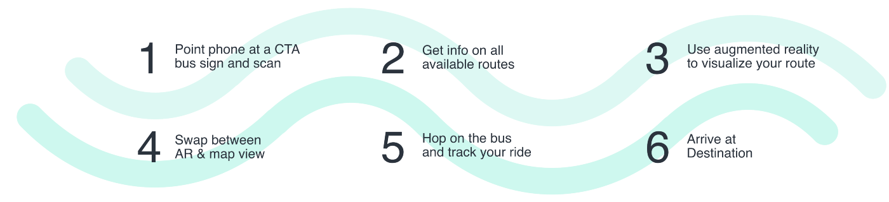
* Involved tracking technology for the bus stop, buses using that bus stop and GPS of current location.
* “One of our primary design goals was to provide only the functionality necessary at each phase of the experience.”
  + focused on only current critical information
  + “For example, if a user is pointing their phone down, the AR visuals are not useful. We provide them with a route map instead. We also maximized the camera view by using vertical screen real estate to display clear, legible bus data.”

**Source 8**: Transport accessibility: <https://gomedia.io/services/transport-accessibility/>

* Trip planning integrated into an application specifically to increase usability in impaired people; visually impaired people who can’t use the physical signage.
* Interesting trip planner feature, with relevant connection to AR app in source 7.

**Source 9**: [Report suggests better reporting of bus shelter vandalism, awareness needed | CityNews Calgary](https://calgary.citynews.ca/2015/01/21/report-suggests-better-reporting-of-bus-shelter-vandalism-awareness-needed/)

* (Report sent in 2015) Calgary bus shelters getting smashed up and graffitied
  + solution was adding protective film or different type of glass
  + tempered glass is the safest option in a bad situation
  + video surveillance is looked into but so far too expensive
  + “The report also stressed the need for timelier reporting of damage.”
* “ While Councillor Andre Chabot suggested an app that would make it easier for bus drivers to let authorities know when they see broken glass or graffiti, Calgary Transit said they planned to provide incentives for employees who spot it. Councillor Evan Woolley suggested bus shelters might be a thing of the past, citing new real-time information that makes it easier for you to wait longer inside your home.

However, Calgary Transit’s Neil McKendrick says shelters are still needed and provide great advertising revenue. ” actual information showing different opinions from government shareholders.

* [Spike in Calgary Transit bus shelter vandalism leaves passengers out in the cold | CTV News](https://calgary.ctvnews.ca/gimme-shelter-calgary-transit-passengers-frustrated-as-rash-of-vandalism-leaves-them-out-in-the-cold-1.5761805) (Report Jan 31, 2022) - a solution to deal with vandalism on bus shelters is still not resolved.

***Source 1****: Reference (APA, Chicago Style or other).*

“Interesting quote 1”

“Interesting quote 2”

“Interesting quote 3”

* Interesting element 1
* Interesting element 2
* Interesting element 3

**and/or** interesting images

* Interesting image 1
* Interesting image 2
* Interesting image 3

# Analyze

1. Look at your interesting quotes and select 5-10 interesting elements (or more if relevant).
2. Write them here (no need to copy-past the quotes again. Summarize what is interesting to you):
3. Organize them into these categories (you can create new categories):

* Phases of the service offered by ETS
* People
  + ETS users (demographics, characteristics, emotions, etc)
  + Other people involved with ETS
* Needs of users
* Touchpoints/Channels (physical and digital) and devices
* Interactions/tasks (what do users do)
* Potential safety issues for users in relation to ETS
* Design opportunities

# Design

Write or sketch 5-10 ideas or design solutions that arose from these readings.